Author’s Guide for Preparing a Paper for the Journal of Computer Science & Technology

First Author1, Second Author1 and Third Author2

1 University Department, University Name City, State ZIP/Zone, Country

*{first_author, second_author}@mail.dom*

2 University Department, University Name City, State ZIP/Zone, Country

*third_author@mail.dom*

[1] **ABSTRACT**

These instructions give you guidelines for preparing papers for the Journal of Computer Science & Technology. The abstract should summarize the content of the paper. Try to keep the abstract below 200 words. Do not make references nor display equations in the abstract. The journal will be printed by photo-offset from the same-sized copy prepared by you. Your manuscript should be printed on A4 paper (21.0 cm x 29.7 cm). It is imperative that the margins and style described below be adhered to carefully. This will enable us to keep uniformity in the final printed copies of the Journal. Please keep in mind that the manuscript you prepare will be photographed and printed as it is received. Readability of copy is of paramount importance.

Keywords: Enter key words or phrases in alphabetical order (5 maximum), separated by commas.

Received 4 December 2014; Revised 7 May 2015; Accepted 17 June 2015

# **IMPORTANT INFORMATION**

The submitted papers must be original. Do not submit a reworked version of a paper you have submitted or published elsewhere. Do not publish “preliminary” data or results. The submitting author is responsible for obtaining agreement of all coauthors and any consent required from sponsors before submitting a paper. The authors must cite relevant prior work.

There is a limit of 7 pages for each paper in the Journal. Each submission should be a .pdf file submitted through the JCS&T management system.

# **PREPARATION OF MANUSCRIPTS**

## **General Appearance**

The text must be in English. The submitted typeset scripts of each contribution must be in their final form and of good appearance since they will be printed directly without any editing. It is essential that the “camera-ready copies” be absolutely clean and unfolded.

Your paper must be printed in actual size in two columns. Columns should be balanced in the last page. The document you are reading is printed in the format that should be used in your paper.

## **Specification**

To ensure uniformity of appearance for the Journal, your paper should conform to the following specifications. If your paper deviates significantly from these specifications, the printer may not be able to include your paper in the Journal.

1) The Top, bottom, left, and right margins should be 2.5 cm.

2) The distance between the two columns of text should be 1cm.

# **FONT SIZE**

The font size must be 10 points. This document is set in 10-point Times. Some technical formatting programs print mathematical formulas in italic type, with subscripts and superscripts in a slightly smaller font size. This is acceptable.

# **MAJOR HEADINGS**

Major headings are to be column centered in a bold font without underline. They must be numbered. "4. MAJOR HEADINGS" at the top of this paragraph is a major heading.

## **Subheadings**

Subheadings should be in a bold font lower case with initial capitals. Also they must be tagged with capital letters in alphabetical order. Last, they should start at the left-hand margin on a separate line.

## **B. Sub-subheadings**

Sub-subheadings are to be in a bold font. They should start at the beginning of the paragraph with no tag. The top of this paragraph illustrates a sub-subheading.

# **ILLUSTRATIONS**

The illustrations can be in color. However, because printed version will be in black and white, you must ensure a clear view in grayscale. Do not supply photocopies. These illustrations should be in place in the article (preferably printed as part of the text rather than pasted up). If you are using photographs and are able to have halftones made at a print shop, use a 100-line or 110-line screen. If you must use photos, they must be pasted onto your manuscript. Use rubber cement to affix the halftones or photos in place. Black and white, clear, glossy-finish photos are preferable to color. Supply the best quality photographs and illustrations possible. Penciled lines and very fine lines do not reproduce well. Do not use tape on your pages.

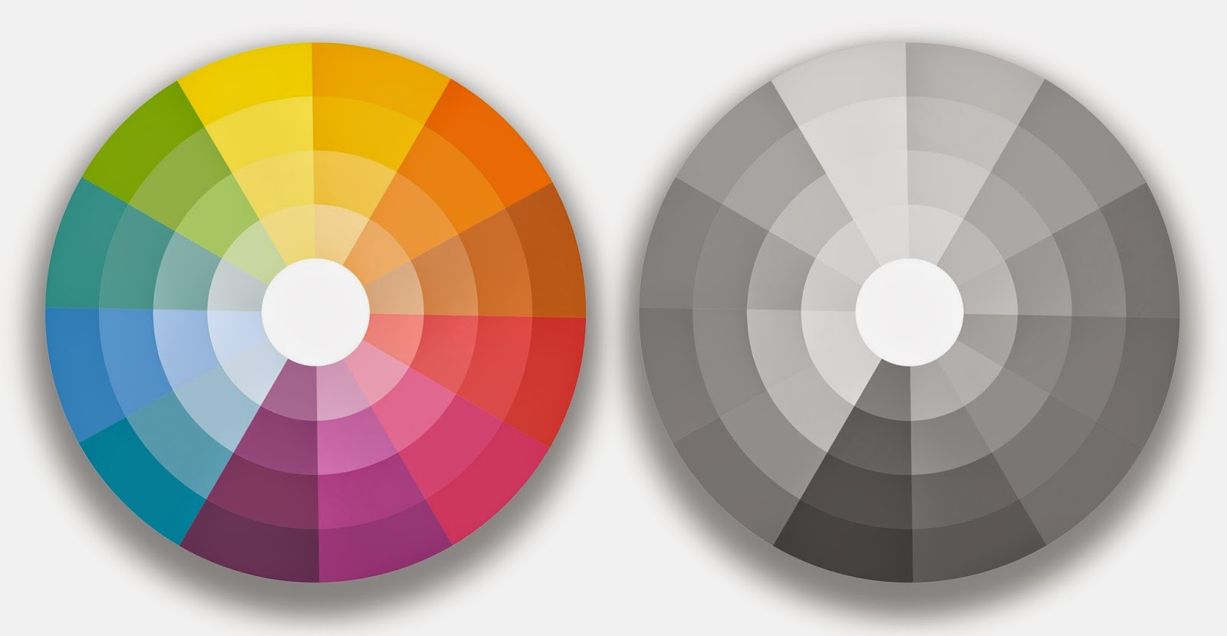

Fig. 1 Sample image.

# **FORMULAE**

All equations must be typed or written neatly in black. They should be numbered consecutively throughout the text. Equation numbers should be enclosed in parentheses and flushed right. Equations should be referred to as Eq. (X) in the text where X is the equation number. In multiple-line equations, the number should be given on the last line. If you are using Word, use either the Microsoft Equation Editor or the MathType add-on (http://www.mathtype.com) for equations in your paper.

${\left(1+x\right)}^{n}=1+\frac{nx}{1!}+\frac{n\left(n−1\right)x^{2}}{2!}+…$ (Eq. 1)

# **TABLES**

Tables must be in black and white.

Table 1 Sample table.

|  |  |  |
| --- | --- | --- |
| **A** | **B** | **C** |
| 1 | 2 | 3 |
| 4 | 5 | 6 |
|  | | |

# **PAGE NUMBERING**

Please do NOT number your pages.

# **FOOT NOTES**

Should be typed in singled-line spacing at the bottom of the page and column where it is cited. Footnotes should be rare.

# **CONCLUSIONS**

The better you look, the better we all look. Thanks for your cooperation and contribution

# **REFERENCES**

List and number all bibliographical references at the end of your paper. The font size must be 9. When referenced in the text, enclose the citation number in square brackets, for example [1]. Where appropriate, include the name(s) of editors of referenced books.

# **ACKNOWLEDGEMENTS**

This paragraph is meant to acknowledgements and support information.

# **REFERENCES**

[1] C.W. Churchman, Book reference, New York: Basic Books Inc. Pub., 1971.

[2] J. Ivari, "Journal reference", European Journal of Information Systems, Vol. 1, No. 4, 1991, pp. 249-272.

[3]E. E. Reber, R. L. Michell, and C. J. Carter, “Technical report,” Aerospace Corp., Los Angeles, CA, Tech. Rep. TR-0200 (4230-46)-3, Nov. 1988.

[4] D. B. Payne and J. R. Stern, “Conference proceedings,” in Proc. IOOC-ECOC, 1985, pp. 585–590.

[5] N. Kawasaki, “M.S. or Ph.D. thesis,” M.S. thesis, Dept. Electron. Eng., Osaka Univ., Osaka, Japan, 1993.

1.